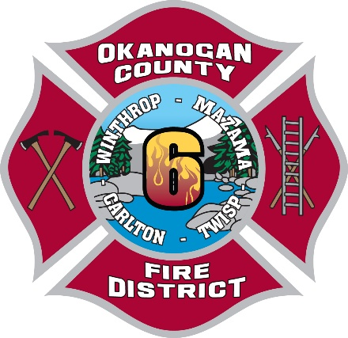
Okanogan County Fire District #6
P.O. Box 895 • Winthrop, WA 98862 • Phone (509) 997-2981 • fax (509) 997-2982
⎯⎯⎯⎯⎯⎯⎯⎯⎯⎯⎯⎯⎯⎯⎯⎯⎯⎯⎯⎯⎯⎯⎯⎯⎯⎯⎯⎯⎯⎯⎯⎯⎯⎯⎯⎯⎯⎯⎯⎯⎯⎯⎯⎯⎯
Commissioners Chief Secretary
Miles Milliken-Chair Cody Acord Jade Gollen
John Lindsey cacord@okanogancountyfd6.com
Sam Heller

PUBLIC NOTICE

OKANOGAN COUNTY FIRE DISTRICT #6

BUDGET HEARING & SPECIAL MEETING
Okanogan County Fire District #6 will hold a Public Budget Hearing to review and take public comment on the proposed 2027 District Budget.
Date: October 26, 2026
Time: 7:00 pm
Location: Okanogan County Fire District #6, District Office, at 33 Horizon Flats Rd., Winthrop, WA 98862.
The purpose of this hearing is to receive public input on the proposed budget before final adoption.
Immediately following the Budget Hearing, the Board of Fire Commissioners will hold a Special Meeting to discuss, consider, and take possible action on adoption of the 2027 Budget.
All interested members of the public are invited to attend.
Copies of the proposed 2027 budget will be available at the hearing.

Posted: October 12, 2026

